• Determine the molecular structure of an unknown sample
List of organic compounds tested:
• Unknown #2 or #3
o UV-vis. (1 spectrum)
o IR (1 spectrum)
o MS (1 spectrum, provided by your instructor, as the machine isn’t properly
calibrated for small organic molecules)
o NMRs (1H, 1H-1H COSY, 13C, 13C DEPT45, 13C DEPT90, 13C DEPT135,
1H-13C HSQC, 7 spectra)
o Total: 10 spectra per unknown sample
Correction Scale for the Report:
- Presentation (each section at its rightful place in the report) ............................... /5
- Molecule (properly drawn and with numbering) ................................................. /5
- Spectroscopic Data (properly written) ............................................................... /20
- Discussion (review all important information from each spectrum) ................. /70
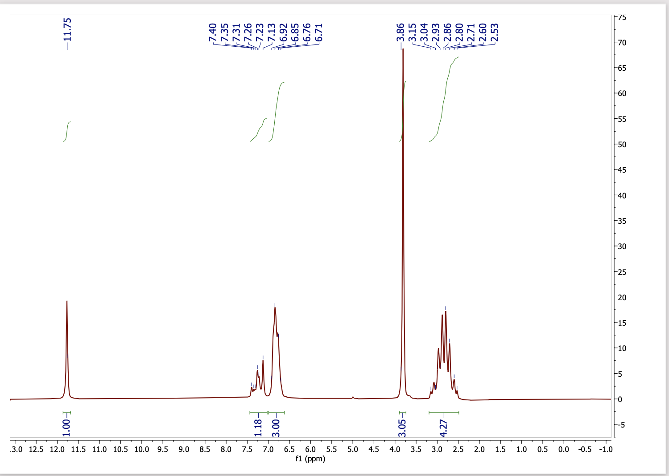
1D 1H unknown 2
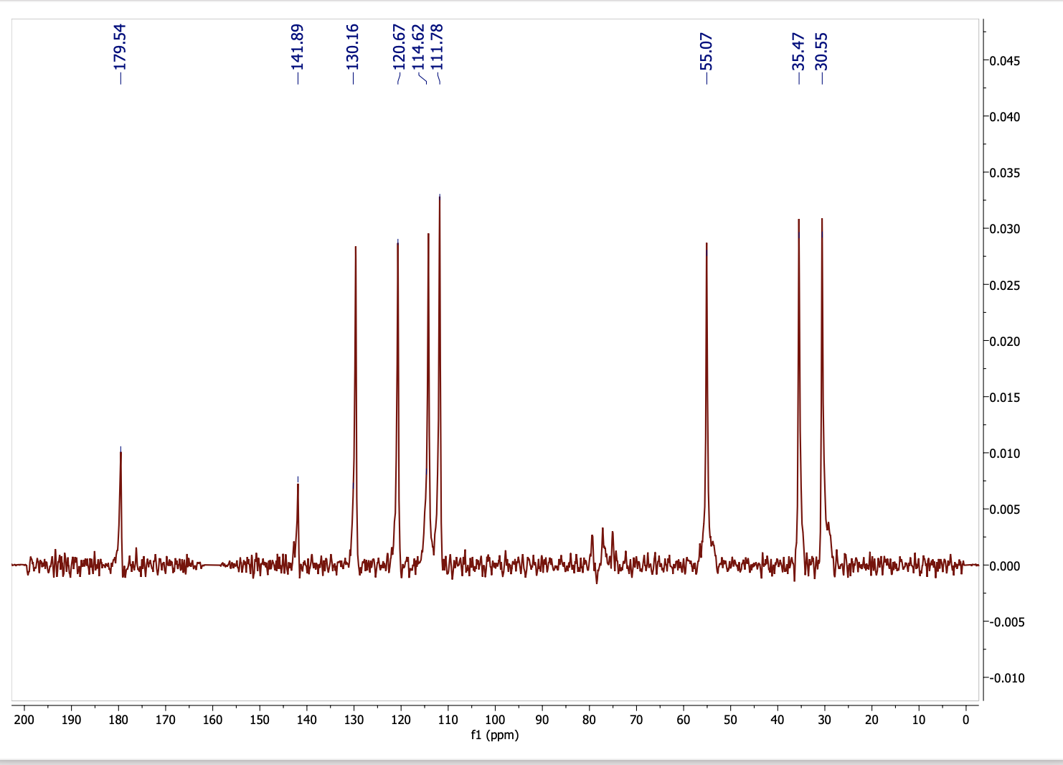
13 C unknown2
here is the list of peaks you should see and analyze in standard 13C NMR for the unknown #2:
13C NMR: δ (ppm, in CDCl₃ at 15 MHz) 180, 160, 142, 130, 121, 115, 112, 55, 35, 31

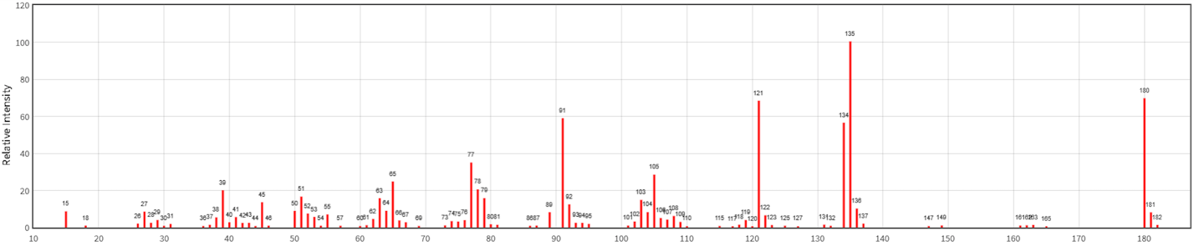
Unknown MS

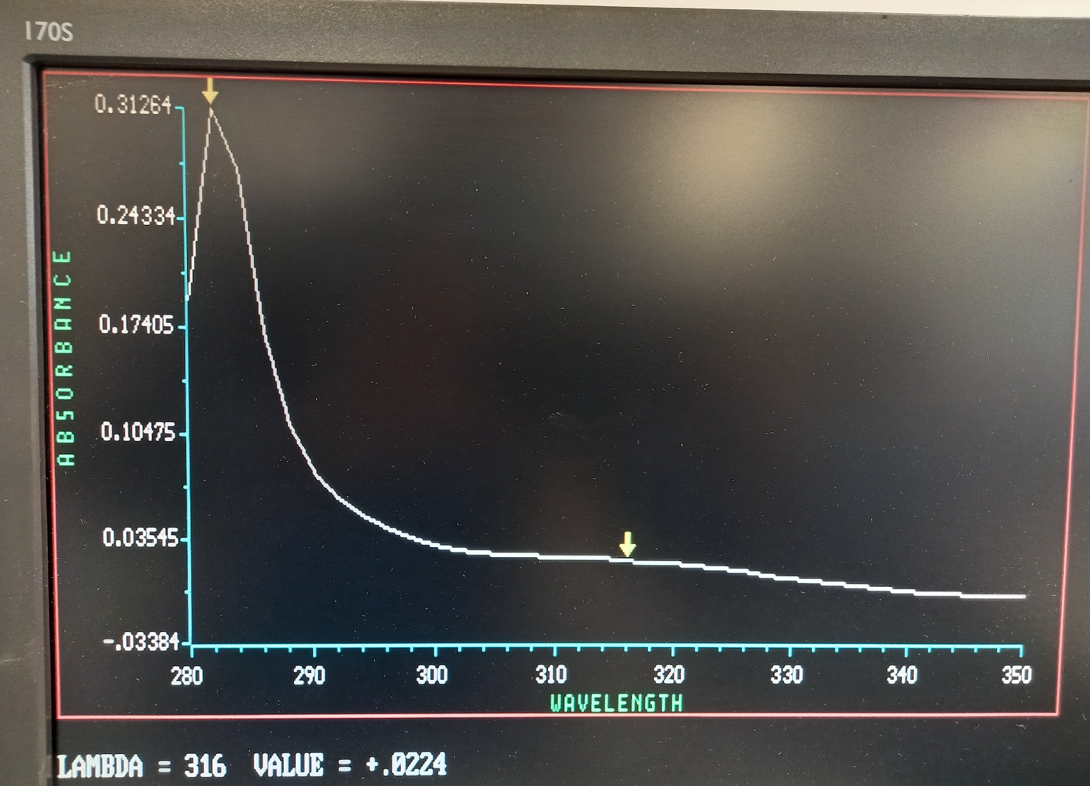
Unknown UV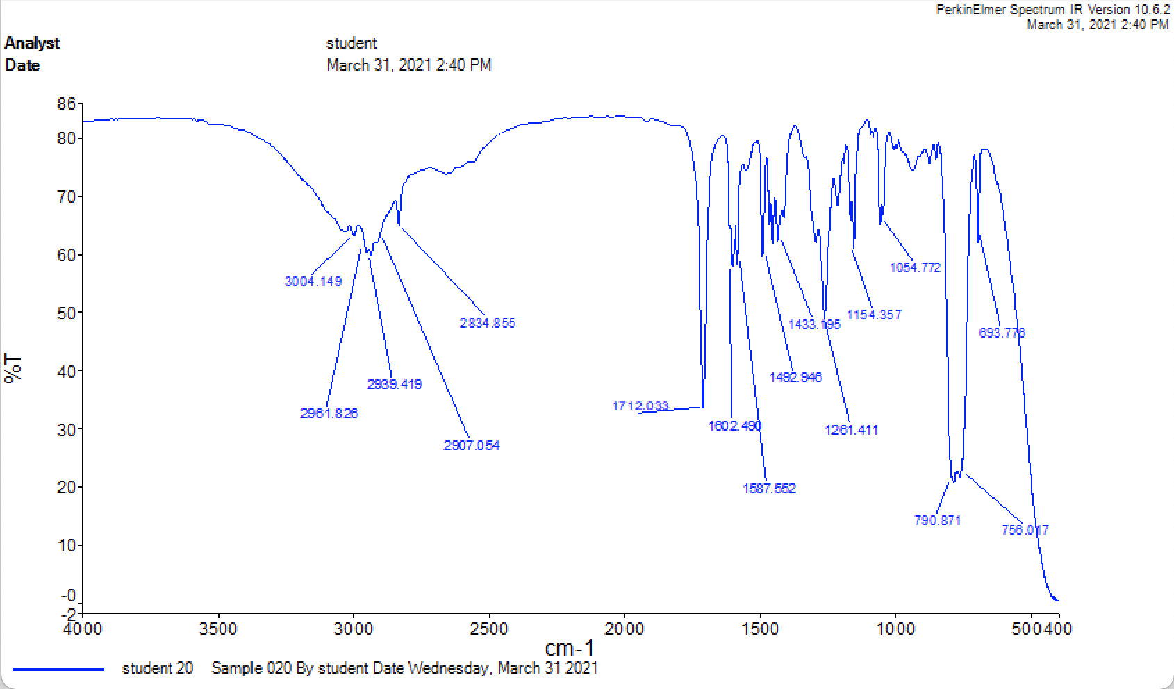
Unknown IR

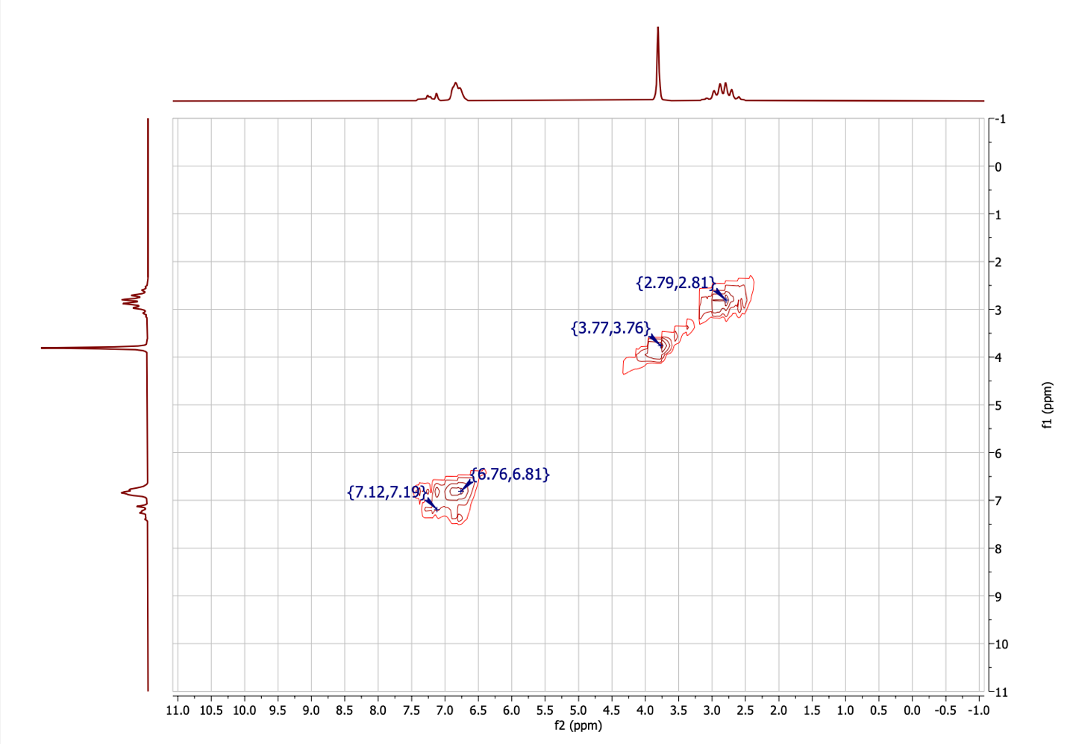
Cosy unknown2

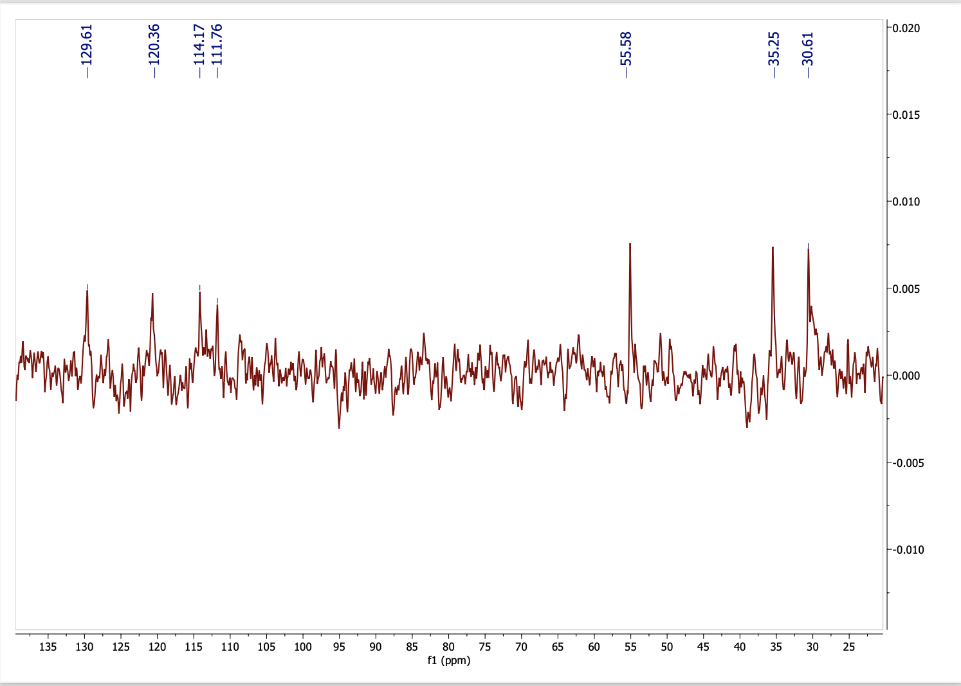
Dept 45_13 C Unknown2
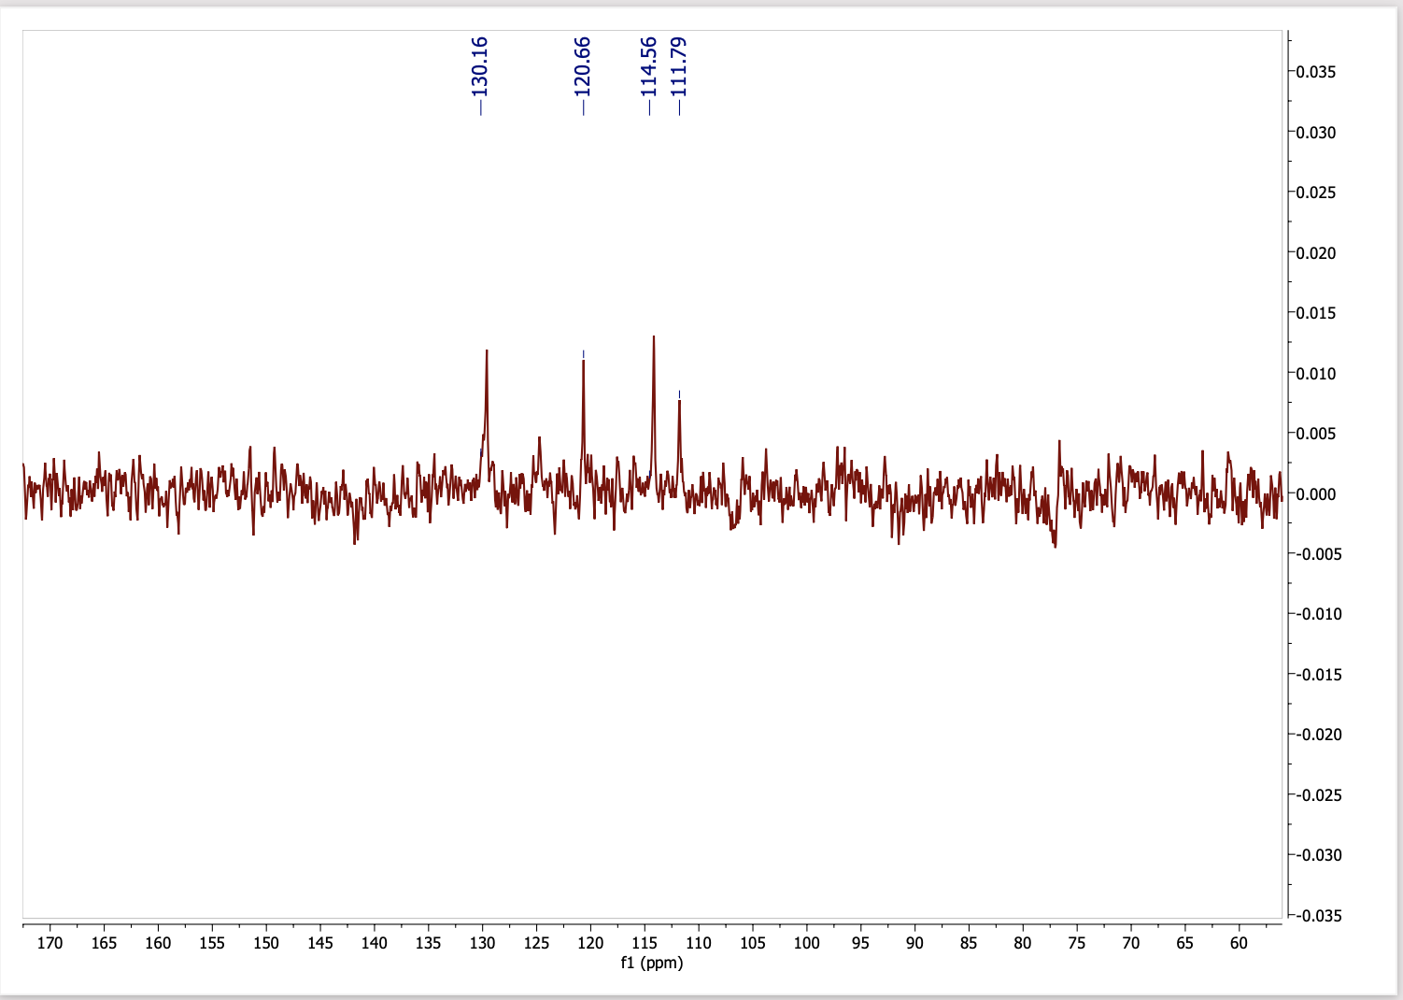
Dept90_13 C unknown2

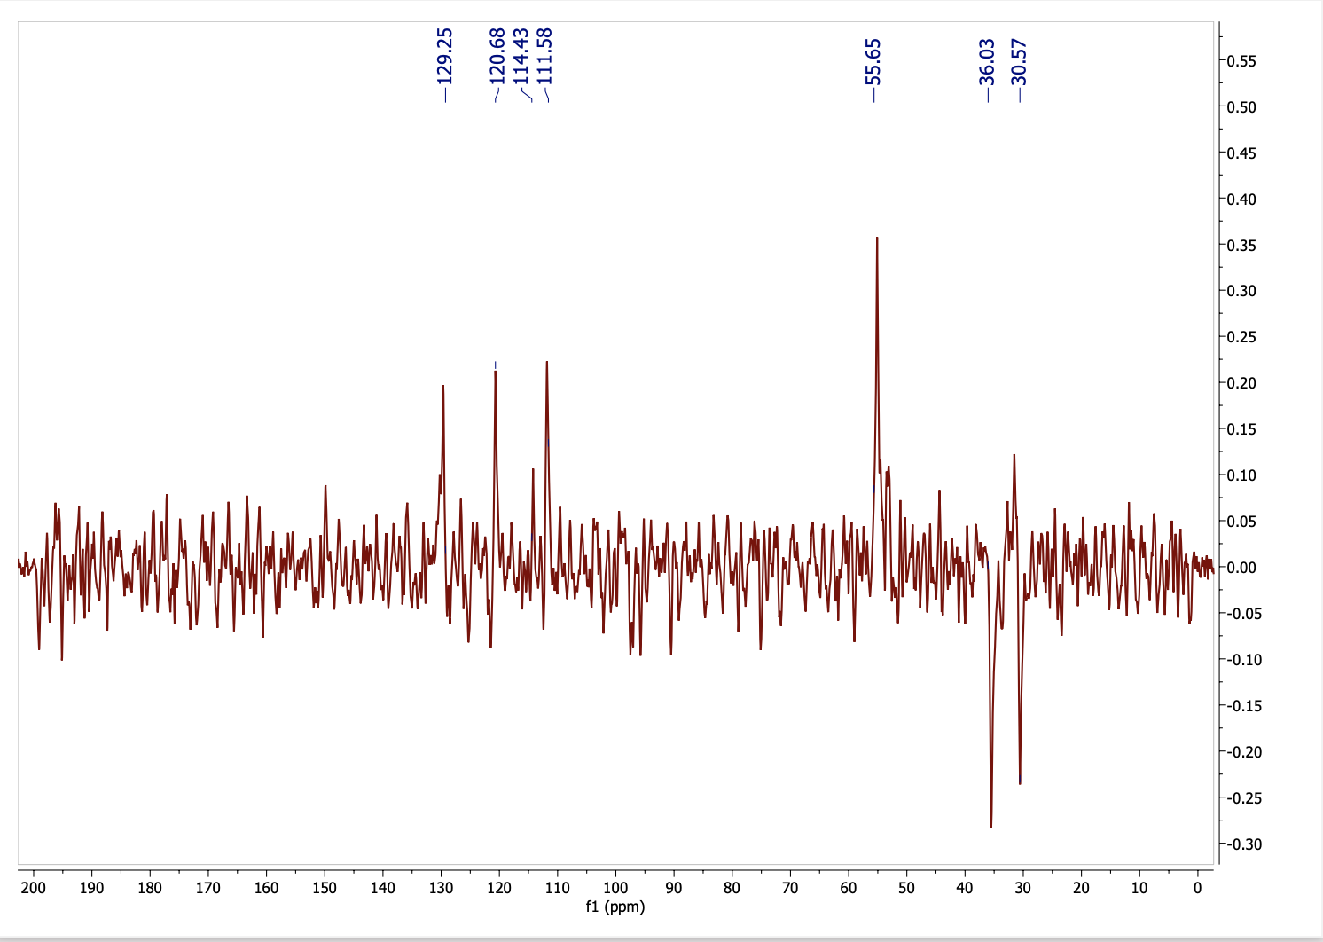
Dept135_ 13 C unkown2
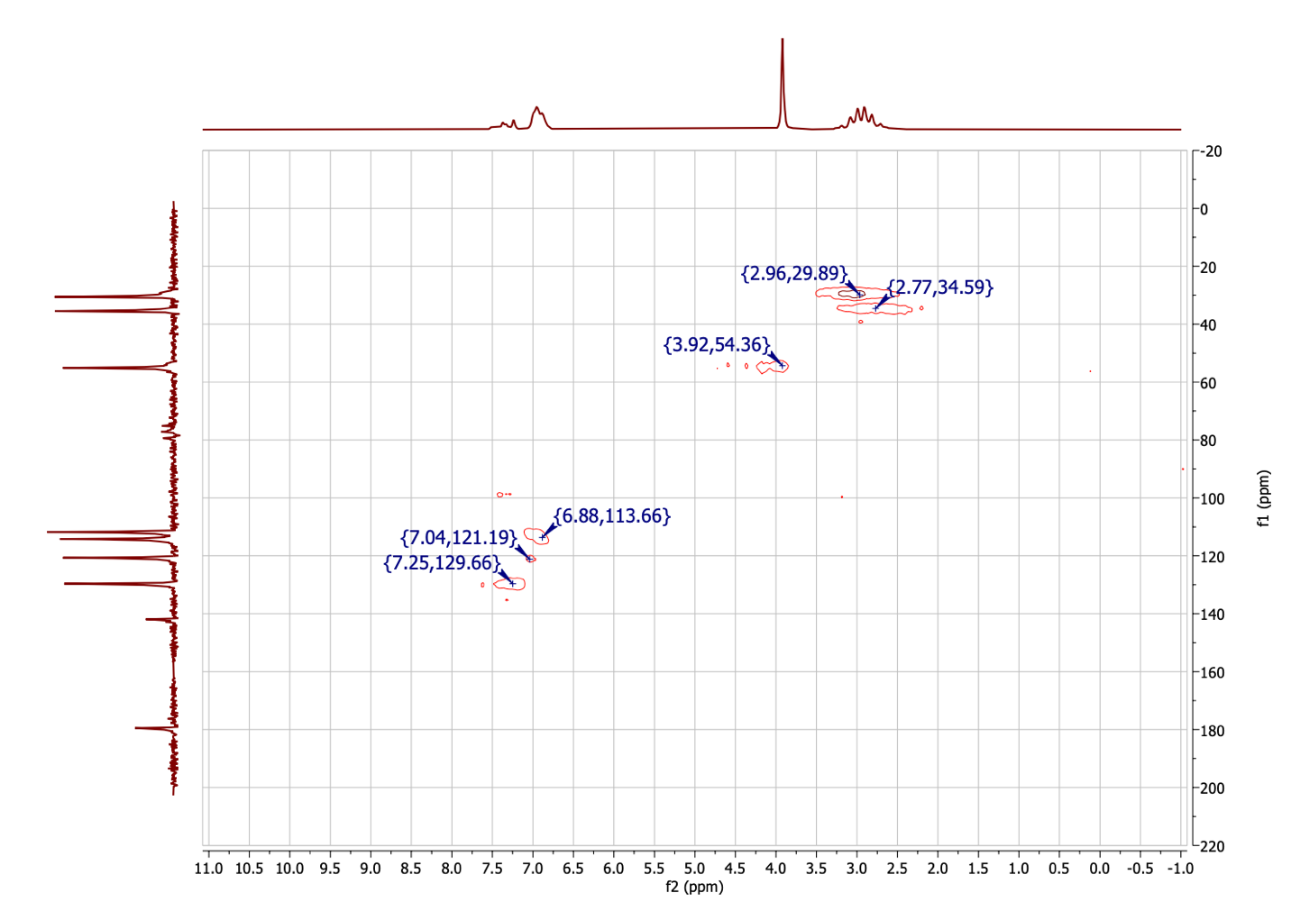
HSQC Unkown2

Supplementary Information:
Unknown #2
UV-Vis.:
There are 2 peaks that were observed in UV-visible spectroscopy, which have the following data:
- 282 nm, absorbance of 0.31
- 316 nm, absorbance of 0.02
Measurements were done in methanol.
IR:
Sample was dissolved in CCl4 (tetrachlorocarbon) to perform the measurements using KBr salt disks.
MS:
Mass spectrum was provided from the NIST Chemistry Webbook, as seen online on March 28, 2021: https://webbook.nist.gov/chemistry/
Ionization source was electron impact (EI).
NMRs:
NMRs were acquired in CDCl3 (deuterated chloroform). 1H, COSY and HSQC were done at 60 MHz, while 13C and the DEPT trio were done at 15 MHz. *Note that for 2D NMRs, you do not need to provide the frequency (but you can if you want to).

